Restaurant Backend Server
Assignment 2 – Hardcoded Menu Server

const express = require("express");
const app = express();

app.use(express.json());

Restaurant Information
const restaurant = {
name: "FoodHub Restaurant",
location: "Rawalpindi",
contact: "+92 300 1234567"
};

Menu Data (Catalog)
const menu = [
{
id: 1,
name: "Margherita Pizza",
price: 12,
category: "Pizza",
image: "https://images.unsplash.com/photo-1600891964599-f61ba0e24092"
},
{
id: 2,
name: "Cheese Burger",
price: 10,
category: "Fast Food",
image: "https://images.unsplash.com/photo-1550547660-d9450f859349"
},
{
id: 3,
name: "Chicken Biryani",
price: 8,
category: "Pakistani Food",
image: "https://images.unsplash.com/photo-1631515242808-497c3fbd3978"
},
{
id: 4,
name: "Pasta Alfredo",
price: 11,
category: "Italian",
image: "https://images.unsplash.com/photo-1621996346565-e3dbc353d2e5"
},
{
id: 5,
name: "Chocolate Milkshake",
price: 5,
category: "Drinks",
image: "https://images.unsplash.com/photo-1572490122747-3968b75cc699"
}
];

Home Route
app.get("/", (req, res) => {
res.json({
restaurant: restaurant,
message: "Welcome to FoodHub API",
endpoints: {
menu: "/menu",
singleItem: "/menu/:id",
search: "/search?name=item",
order: "/order"
}
});
});

Get Full Menu
app.get("/menu", (req, res) => {
res.json({
totalItems: menu.length,
menu: menu
});
});

Get Single Menu Item
app.get("/menu/:id", (req, res) => {

const id = parseInt(req.params.id);

const item = menu.find(m => m.id === id);

if (!item) {
return res.status(404).json({
message: "Menu item not found"
});
}

res.json(item);
});

Search Menu

app.get("/search", (req, res) => {

const name = req.query.name;

const results = menu.filter(item =>
item.name.toLowerCase().includes(name.toLowerCase())
);

res.json({
results: results
});

});

Order Endpoint

app.post("/order", (req, res) => {

const order = req.body;

const orderDetails = {
orderId: Math.floor(Math.random() * 10000),
time: new Date(),
customer: order.customerName,
item: order.item,
quantity: order.quantity
};

console.log("📦 New Order Received");
console.log(orderDetails);

res.json({
message: "Order placed successfully",
order: orderDetails
});

});

Server Start
const PORT = 3000;

app.listen(PORT, () => {

console.log("🚀 FoodHub Server Running");
console.log(`Home: http://localhost:${3000}`);
console.log(`Menu: http://localhost:${3000}/menu`);
console.log(`Search Example: http://localhost:${3000}/search?name=pizza`);
});

Server running:
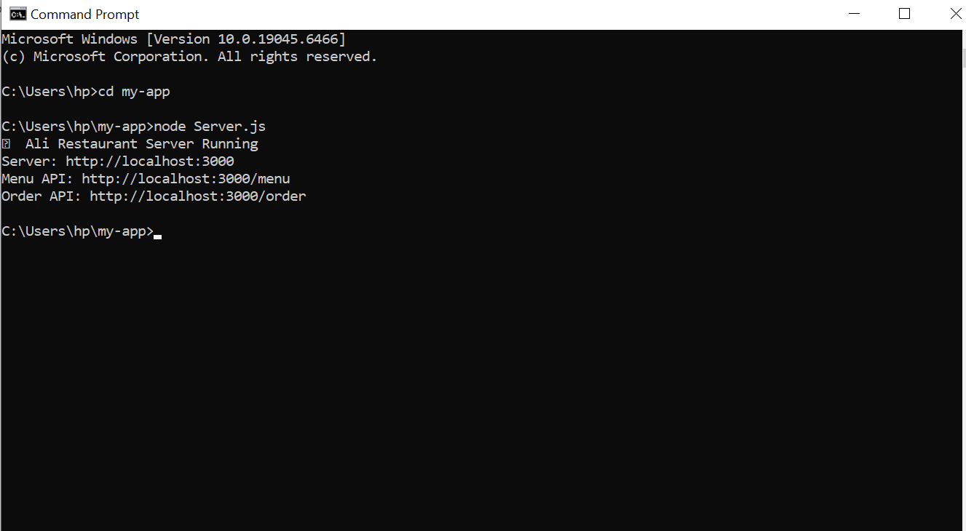

MENU CATALOG:
